Course Title: | Access to Higher Education Diploma –
Unit Title: | Cardiopulmonary System
Unit: Level: | 3 | Credit Value: | 3
Tutor Name: | Alison Read
Student Name:

Task Number:  (if applicable) | A report containing Tasks 1,2 and 3
Task Title: | Cardiopulmonary System
Date Set: | 10 December 2020 | Date Due: | 14 January 2021 (18:00)
Extension Agreed: |  | Date of Return to learner:
Date of Resubmission: |  | Resubmission Return to learner:

Student declaration of authenticity
I confirm that the assignment I have submitted is all my own work and that it has been appropriately referenced in line with the centre policy on referencing of submissions of academic work
Signature of student:
Date submitted:

WORK SUBMITTED AFTER THE DEADLINE WILL BE CONSIDERED FOR PASS ONLY

IV declaration
I agree this assignment brief is fit for purpose and assesses the identified criteria.

IV Signature | M.Jenkins | Date: | 22/11/2020

Grade Profile Achieved for Assignment | GD1 | GD2 | GD4 | GD7 | Final unit grade, if applicable *

Learning Outcomes | Assessment Criteria
1. Understand the circulatory system. | 1.1. Investigate the structure of the  mammalian heart.  1.2. Analyse the cardiac cycle and explain  how it is initiated and controlled by the  heart’s electrical activity.  1.3. Compare and contrast types of blood  vessel.  1.4. Describe the structure and function of a  red blood cell.
2. Understand the respiratory system. | 2.1. Identify gross anatomical structures of  the respiratory system and relate to  function.  2.2. Explain how the microscopic structure of  an alveolus relates to its function.  2.3. Investigate changes in ventilation at rest  and after exercise, and relate to  homeostasis.
3. Be able to investigate the pathologies of  the cardiopulmonary system. | 3.1. Produce a case study on a named  disease that affects the cardiopulmonary  organs.

Description of Assessment Task (mapped to Assessment Criteria)
This assignment can be laid out as a report. Label each task (Task 1.1 etc.) Reports may include subheadings, bullet points, tables and images however; they should also include sentences / paragraphs written in an academic tone with correct use of appropriate terminology. Work should be referenced as per Harvard referencing guide.

Task 1.1
Carry out a dissection of a mammalian heart in class and take a photograph of the dissected heart.
Alternatively, watch the video on the cloud of a mammalian heart dissection and make notes. Obtain a photograph of a dissected mammalian heart and label the structures that you can identify. (Not included in word count). (AC 1.1).

Task 1.2
Using suitable diagrams explain how the cardiac cycle is initiated and controlled by the heart’s electrical activity (approx 150 words) (AC 1.2).

Task 1.3
Arteries, capillaries and veins are different types of blood vessel in the human body. Illustrating your answer with suitable diagrams, explain the similarities and differences between capillaries, arteries and veins. You may wish to use a table to format your answer (approx 150 words) (AC1.3).

Task 1.4
Write a short section of approx 500 words or less, Describe the structure and function of a red blood cell (AC1.4).

Task 2.1
Numerous structures make up the human respiratory system. In the diagram below, the labels have been replaced with numbers.

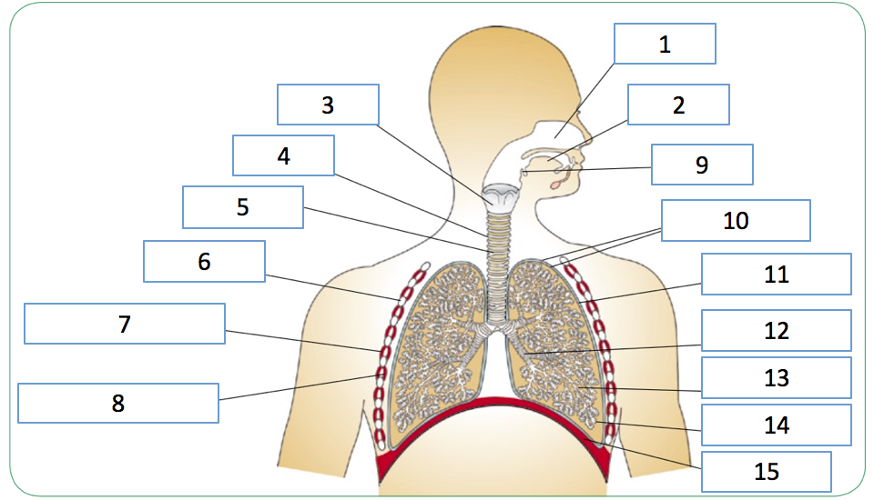
For each number, provide the name of the corresponding structure and briefly describe how the structure is related to function. (Not included in word count) (AC 2.1)

Task 2.2
Alveoli are the smallest functional units of gas exchange in our lungs. The diagrams below illustrate alveolar structure.
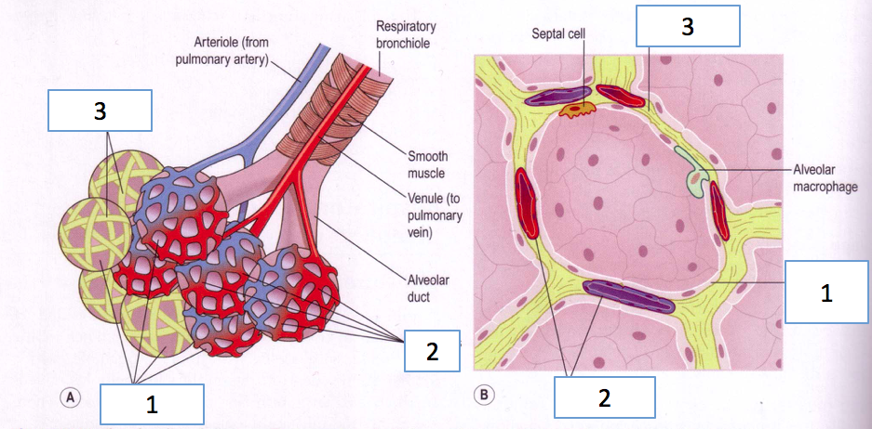

Explain how the microscopic structure of an alveolus relates to it’s function. In your explanation you should refer to the above figure and provide the names for the numbered structures (Not included in word count). (AC 2.2).

Task 2.3a
Use the diagram below to explain lung volumes and capacities at each numerical label (Not included in word count).

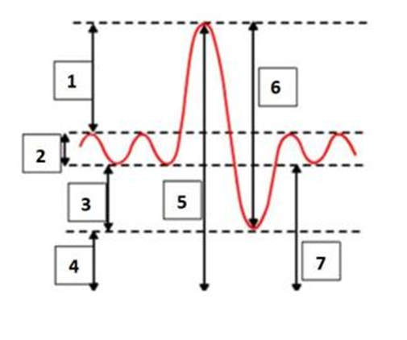
Task 2.3b
Explain how ventilation changes between rest and exercise and how this contributes to homeostasis (approx 350 words) (AC 2.3).

Task 3.1 Produce a clear, relevant and well-researched case study on a named disease that affects the cardiopulmonary organs. This could include, but is not limited to, any of the following: coronary artery disease, myocardial infarction, cardiomyopathy, asthma, emphysema or pneumonia.
This assessment could be formatted as an academic report, poster or presentation (approx 250 words) (AC 3.1).

Grading Information
If you have achieved all Level 3 criteria you will receive a grade (Pass, Merit or Distinction) against the following Grade Descriptors. The grade awarded will be determined by your aggregated performance against the Grade Descriptor Components noted below. The boxes below each Grade Descriptor provide contextual statements which relate the language of the Grade Descriptor to the set assignment task. These statements will help you to know what is required at the identified Grade Descriptor and also to understand the Grade Profile that you have been allocated.

Grade Descriptor  (Insert more rows as necessary) | To achieve a Merit:  The learner has | To achieve a Distinction:  The learner has | Grade Awarded
GD 1 Understanding of the subject | Demonstrated a very good grasp of the relevant knowledge base | Demonstrated an excellent grasp of the relevant knowledge base
What this means for the assignment | Demonstrate a good understanding of the topic and evidences research around it. | Demonstrate an excellent understanding of the topic and evidences research around it.
GD 2 Application of knowledge | The student, student's work or performance:  a) makes use of relevant  • ideas  • facts  • theories  • perspectives  • models  • concepts  with  b) breadth or depth that goes beyond the minimum required to Pass | The student, student's work or performance:  a) makes use of relevant  • ideas  • facts  • theories  • perspectives  • models  • concepts  with both  b) breadth and depth
What this means for the assignment | Evidence that the assignment has been well thought out and that the field of study has led to a great understanding of the topic that is used appropriately in the tasks. | Evidence that the assignment has been extremely well thought out and that the field of study has led to a great understanding of the topic that is used appropriately in the tasks.
GD 4 Use of information | a) identifies new information from sources which are generally appropriate  b) makes some use of new information  c) generally appraises the relevance and value of new information accurately  d) shows a very good grasp of the meaning and significance of new information  e) generally combines or synthesises  information with outcomes that are accurate and appropriate | a) identifies new information from sources  which are consistently appropriate  b) makes extensive use of new information  c) consistently appraises the relevance and value of new information accurately  d) shows an excellent grasp of the meaning  and significance of new information  e) consistently combines or synthesises information with outcomes that are  accurate, appropriate and  • succinct  • innovative  • creative
What this means for the assignment | Evidence that the student has carried out wider reading and research from at least 6 additional quality sources. | Evidence that the student has carried out wider reading and research from extensive quality sources (at least 8).
GD 7: Quality | a) is structured in a way that is generally logical and fluent  b) puts forward arguments or ideas which are generally unambiguous but which are in a minor way limited or incomplete  c) taken as a whole, demonstrates a very good response to the demands of the brief/assignment | a) is structured in a way that is consistently  logical and fluent  b) puts forward arguments or ideas which are consistently unambiguous and cogent  c) taken as a whole, demonstrates an excellent response to the demands of the brief/assignment
What this means for the assignment | The assignment is clearly organised and structured and presents a very good response to the tasks set. The work is written in clear ‘academic English’ as required for a piece of technical writing. There may be some errors in the development of argument and some structural inconsistencies, but overall the work presents a very good response. | The assignment is consistently well -organised and structured and presents an excellent response to the tasks set. The work is consistently written in clear ‘academic English’ throughout as required for a piece of technical writing of this nature. There may be some minor errors in the development of argument and minor structural inconsistencies, but overall the work presents an excellent / outstanding response.

Assessor's comments

Tutor Feedback
Individual feedback and targets for improvement and any comment in relation to resubmission (if appropriate):  Please also refer to the ‘What this means for the assignment’ boxes on page 3 in terms of understanding the rationale for the grade judgments allocated to the different Grade Descriptor Components. | Areas for Improvement: | Tick
 | Spelling
 | Punctuation
 | Grammar
 | Structure
 | Referencing
 | Signposting
 | Content

Tutor Signature: |  | Date:

Internally Moderated by: (if applicable)
Date/s:

If there is more than one assignment for a unit, the final provisional grade for the unit cannot be awarded until all assignments have been completed, and this space should be left blank.

